



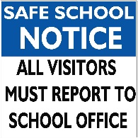
Important Dates

May 1: Last swim day for POP/WILD classes

May 7: Hot Lunch

May 12: Salmon Release Ceremony

May 13: Staff mtg 3 p.m.

May 14: Hot Lunch

May 18: Victoria Day; school closed

May 21: Hot Lunch

May 25: Pro-D; school not in session

May 27: Salmon Feast

May 28: Hot Lunch

Dear WEG Families,
As we step into May, there’s a noticeable shift in energy throughout our school. Classrooms are buzzing, projects are coming together, and our students are rising to the challenge as we head into the final stretch of the school year. The next two months are an important time for consolidating learning, celebrating growth, and finishing strong—both academically and as a community.
Our staff continue to be intentional in supporting students as expectations remain high, while also ensuring that classrooms are engaging, supportive, and focused. We encourage families to help maintain consistent routines at home, as this time of year can feel especially busy for students. Welcome back to our OELP students who recently visited Bamfield!

We are currently seeking volunteers to assist with taking inventory in the foods room, as well as helping prepare handheld breakfast options for students. If you are available to support with either of these opportunities, please contact the school—we would greatly appreciate your help.
Our PBIS focus for May is Perseverance—Finishing Strong. Throughout the month, we will be encouraging students to stay committed to their goals, push through challenges, and take pride in their efforts right to the end of the school year. Whether it’s completing assignments, preparing for assessments, or continuing to show kindness and respect, perseverance will be at the heart of our work together.
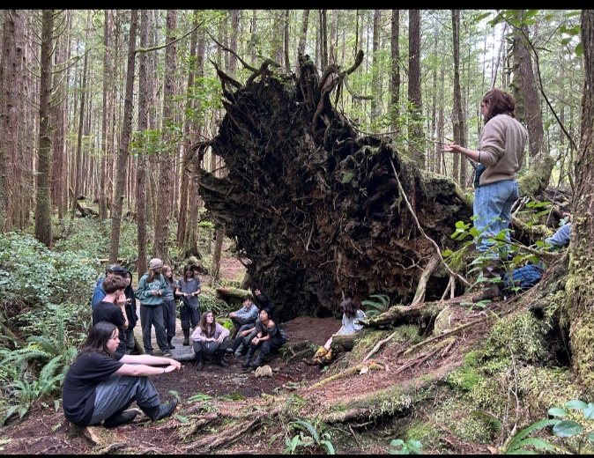
Thank you, as always, for your continued partnership and support. Together, we can make these final months meaningful and successful for all our students.



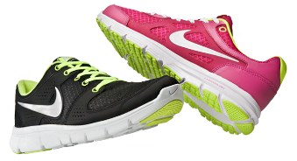
**To help preserve the life of our gym floor, only indoor shoes are permitted. Please ensure that your child has a pair of appropriate indoor shoes at school.



