



Important Dates
March 5: Hot Lunch
March 12: Hot Lunch
March 13: Last day before Spring Break
March 13: Report cards go home
March 14-29: Spring Break; classes not in session
March 30: Back to School

Dear Families,
Thank you so much for your support of our Family Game Night! It was an overwhelming success and a fantastic fundraiser for the OELP class in their efforts to raise money for their fieldtrip to Bamfield next month. It was wonderful to see so many families come out and enjoy the evening together.
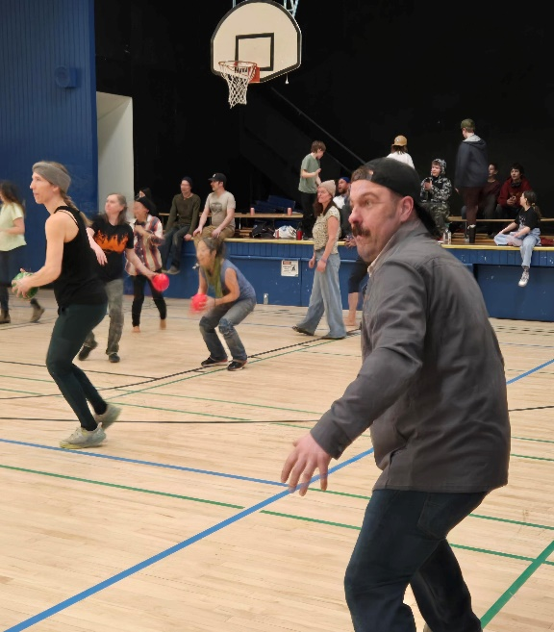
The dodgeball tournament was incredibly popular, the baking and pizza were a huge hit, and we even managed to sell a number of raffle tickets throughout the night. Most importantly, it was a fun time had by all!
A special thank you goes to Ms. Goldie and Ms. Fredrickson for organizing student help and assisting with setting up for the event. Your support helped make the evening run so smoothly.
If you would still like to support the OELP class, there are a few ways to do so:
- Purchase raffle tickets at the office
- Order Purdy’s chocolates online https://fundraising.purdys.com/campaign/000025877
- Contribute to the class GoFundMe campaign https://gofund.me/0ab66386f

Thank you again for helping make this event such a memorable and successful evening for our school community!

Our PBIS theme for March is: March Forward with Respect.

This theme focuses on supporting students in continuing to grow by showing respect for themselves, for others, and for our school. As we move into this next stretch of the year, it’s a great opportunity to reteach, reinforce, and acknowledge the positive choices students are making each day.
Just a friendly reminder to have your child bring home their belongings from the coat area so that the shelves may be cleaned over the break. In addition, ensure there are no food items left in their desks.

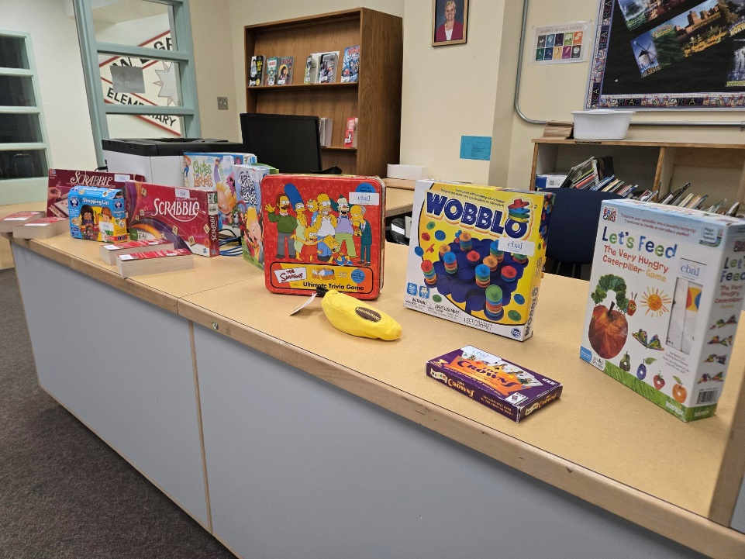

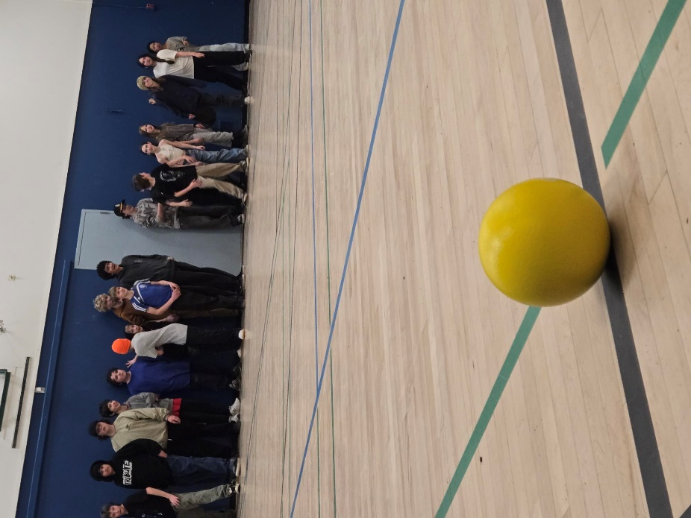

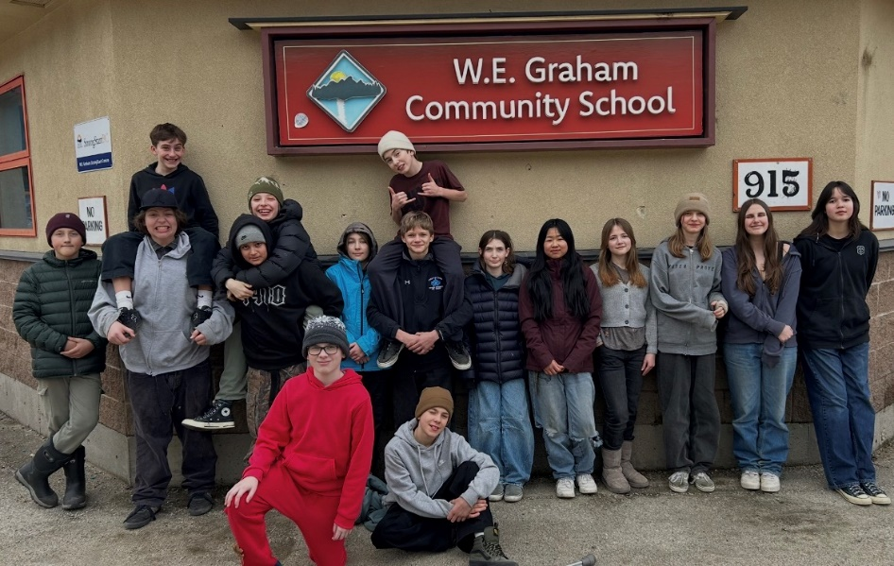
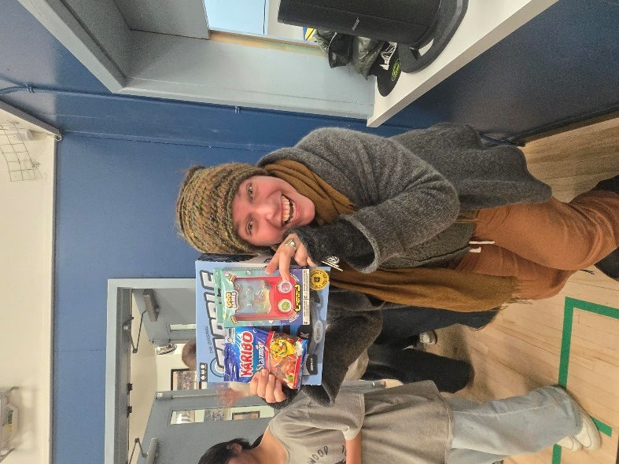
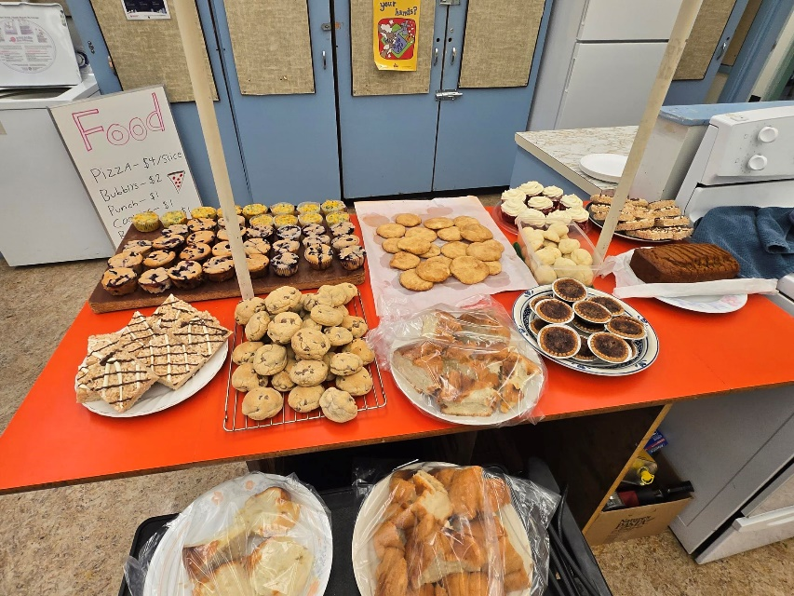

The P.O.P class had a wonderful day with guest educator Snow Crystal, from the Wildsight Program. We spent the entire morning outside learning about animals and animal behaviour, playing games, and testing our memory. The students are now working on finishing their beaver study unit and are excited to share their knowledge. Be sure to check out our mural in the hallway.
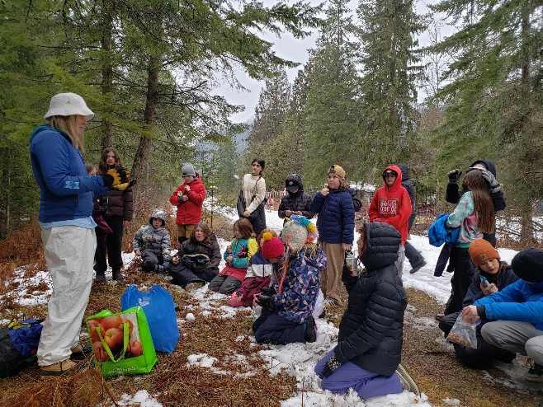
The grade 4,5,6 class had a local Winter Wonder field trip with an environmental educator from Wildsight. By building a shelter to keep their baby ptarmigans warm (hot baked potatoes), the kids learned about thermal energy transfer and what materials act as conductors or insulators. We were lucky there was still some snow that day!
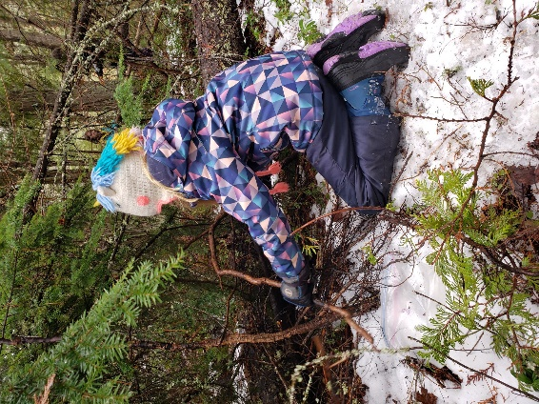


VWP successfully completed their 3 day winter camping ski trip up at Whitewater. Students showed enthusiasm and resilience!


Wishing you all a wonderful Spring Break! See you back at school on March 30!

