



Welcome back, and Happy New Year!
Important Dates

January 5: First Day back after the break

January 14, 21, 28, February 4, 11: School Ski Days at Whitewater

January 15: Hot lunch

January 19: District Pro-D; no school for students

January 22: Hot Lunch

January 29: Hot Lunch

January 27-30: VWP Silverstar Trip
We are so happy to have our students back at school and to see our classrooms full of energy again. We hope your family had a relaxing and enjoyable Christmas break, with time to rest and reconnect. As we begin this new year together, we are looking forward to a positive and productive month ahead. January also brings some exciting opportunities, including our upcoming school ski days, which many students eagerly anticipate. Please ensure you have completed your registration forms and paid the associated fees.

Our PBIS focus for this month is self-regulation, and students will be learning strategies to help them recognize their feelings, manage big emotions, and make positive choices throughout the day. Families can support this at home by encouraging children to talk about their feelings and practice calming strategies when needed. Thank you for your continued partnership and support—we look forward to a great month together.
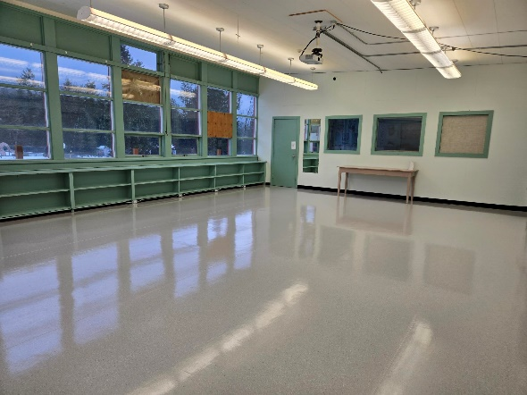
We are also excited to share that new flooring has been installed in the Grade 7/8 classroom over the break. This update has completely transformed the space, creating a brighter, more welcoming, and more functional learning environment for our students. We are very appreciative of the work completed during the holiday break to make this improvement possible. A special thank you to our Operations Department for their time, effort, and commitment to supporting our school. We are grateful for their dedication to ensuring our learning spaces are safe, comfortable, and ready for students.
Kindergarten Registration





Registration is now open for the upcoming school year. Children registering for Kindergarten must be turning five years old by December 31, 2026. Families may stop by the school office to pick up registration forms, or complete the process online by visiting: https://www.sd8.bc.ca/registration. For more information, please contact the school at 250-355-2212.

