



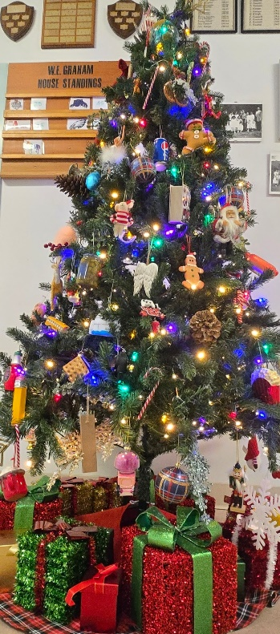
Important Dates
December 4: OELP Campout
December 4: Hot Lunch (breakfast for lunch)

December 5: Report cards go home

December 9: PAC mtg 6 online only

December 11: Hot lunch (burritos)

December 12: OELP to Nakusp Hot Springs

December 16: Christmas Concert 5:00 p.m. in the gym

December 18: Hot Lunch (Poke bowl)

December 19: Last day of School before Winter Break

January 5: Back to School



Dear WEG Families,
As we enter the month of December, we are focusing on our PBIS theme: “Chill Out & Choose Self-Control.” During this busy and exciting time of year, we are teaching students how to pause, take a breath, and make calm, po
sitive choices. Students will practice noticing their feelings, using simple calming strategies, and solving problems in peaceful ways.
We appreciate your partnership in helping our students grow socially and emotionally. Together, we can support our children in staying focused, kind, and in control throughout the holiday season. Thank you for all you do, and we wish your family a warm, joyful December!
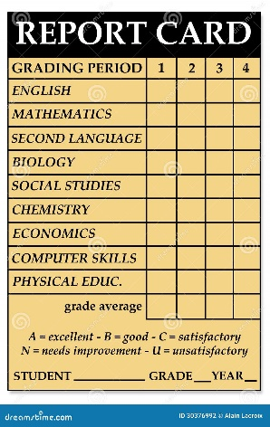
Your child will be bringing home their report card on Friday. Our teachers dedicate many hours to creating these reports so you receive the most accurate and up-to-date picture of your child’s growth and progress during the first term. We encourage you to take some time to sit with your child to review the report, celebrate their hard work and successes, and talk together about any areas where they can continue to grow. Your partnership helps reinforce the importance of effort, reflection, and learning, and we truly appreciate your support.

Ski forms went home yesterday. Our first ski day at Whitewater is January 14 and runs for 4 consecutive weeks thereafter. Please note that due to a shortage of drivers, we are only able to take one bus to the hill. If you are able, we ask that parents drive their students where possible. This will allow all of us to get to the hill and have some fun. If you have any questions, please call the office at 250-355-2212.

On behalf of staff, I would like to wish you and your family all the best this holiday season! See you in January 2026!

