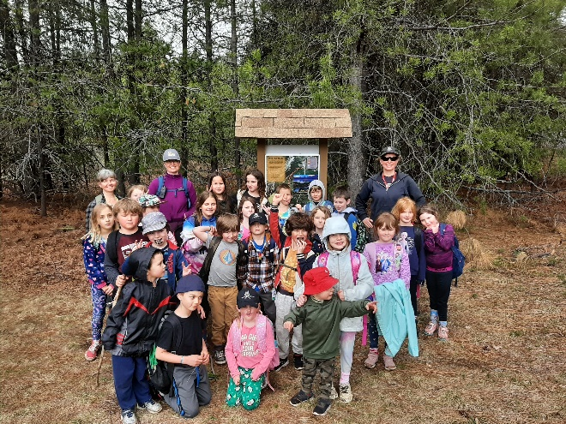
AROUND THE SCHOOL!
VWP: Most of you heard that we weren’t able to get our VWP out for their winter camping trip. The week that it was planned was projected to be minus 29 Celsius. That was followed by a week that was close to 0 and became an avalanche risk. Mr. Marechal and the children were really disappointed, but the weather is the ultimate decider for our trips. Since then they have been out for a wet bike trip and they’re leaving Sunday for their (hopefully a little dry) canoeing trip! Fun fact! Next year will be Sean’s 25th year of running the program!
OELP
The Grade 7/8 Class is cruising along with their work. They’ve been testing their building skills in Science and seeing how well they can control a marble as it travels along a course they’ve designed. They’ve also started their wood shop, cooking, and coding courses for this last term. They will be heading to Revelstoke for their end of year trip!
Grade 4/5/6 – Mr. Boyes’ class have been designing their own countries complete with flags, maps, businesses and so on! Looks like fun. They are looking forward to a year end trip to the Nelson Pool.
WILD and POP: The WILD class joined the POP class for their Swim Lessons and Activities on Wednesdays. They would leave the school bright and early and do a hike and then attend their swimming lessons at the Castlegar Pool.
WILD and POP at Dove Hill
POP: Are planning their year end trip with a Bike trip at Syringa on June 8th, and another hike toward Evan’s Creek.

WILD: Their year end events will include some hiking and biking and celebrating how well they’ve been working this year. They just came back from helping to replant grasses at the Snk’mip Sanctuary near Hills.

June Events:
We are looking forward to some events for the last week in June:
Monday, June 20 – Track Meet
Tuesday, June 21 – Beach Day
Wednesday, June 22 – Classroom Day
Wednesday, June 22 – VWP Graduation Dinner
Thursday, June 24 – Last day. Students dismissed at 11:45 (Half Day)

Fun at the school:
Our VWP students hosted an Easter Fun day last month. They set up stations for the rest of us to enjoy. It was nice to enjoy some fun!
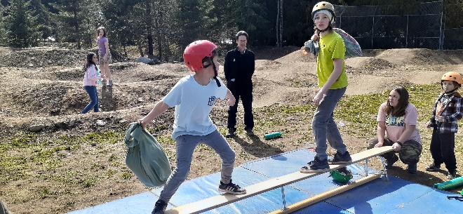

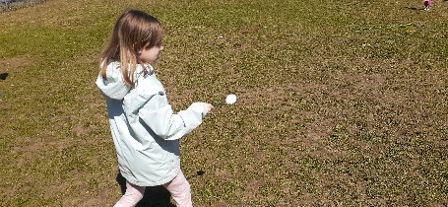

Green Team Update.
The Green Team is beginning their Pollinator’s garden in front of the school. They’ve also started to get everyone moving and doing more recycling in the school!

Hot Lunch: A big thank you to our Hot-Lunch folks who got our program up and running again. It was so nice to have parents helping us out. Iza and Archer’s mom, Rio and Cypress’ mom and grandma, Jasmine’s mom, Raven’s mom, Sage’s mom, and Sam’s mom! We look forward to next year getting started in the fall!

Absences:
If your child is going to be absent, you can use our Website to let us know:
Weg.sd8.bc.ca
Then there’s a tab along the top that says “REPORT ABSENCE”

Click there and it takes you to a form that you fill out and it gets emailed to Shannon!

W.E. Graham Community School Registration 2022/2023
Supporting your Local Community School is a great way to contribute to the building of a healthy and sustainable community in Slocan.

